ASSIGNMENT – 8

Formatting Query output.

Q1) Assume each salesperson has a 12% commission. write a query on the orders table that will produce the orders number, the salesperson number and the amount of salesperson’s commission for that order.

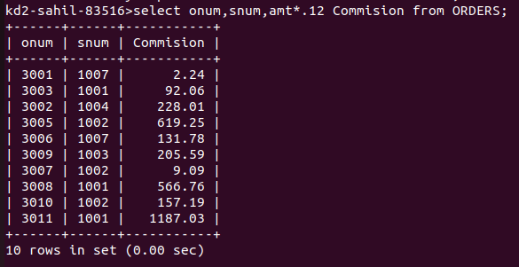

Q2) write a query on the customers table that will find the highest rating in each city. Put the output in this form:
For the city (city), the highest rating is : (rating).

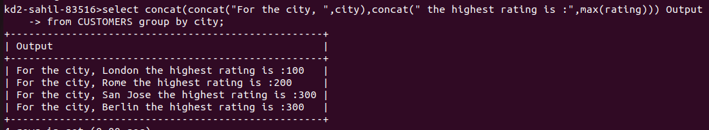

Q3) write a query that lists customers in descending order of rating. output the rating fields first, followed by the customer’s name and number.

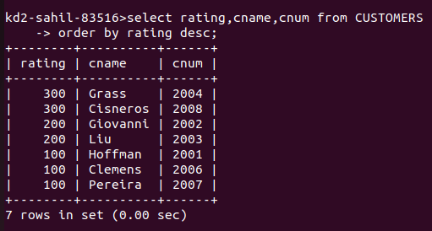

Q4) write a query that totals the orders for each day and places the results in descending order.

